Perspectives from the Peninsula ~ 9
October 21st 2005

Not cheap but worth the investment!
Sparkling Gems from the Greek
Rick Renner
(Teach the Nations)
Available from:
www.amazon.co.uk

Just before we left Shetland, Michael Ross Watson sent us a copy of the book by Rick Renner that we are featuring. He commended it highly, and we have no hesitation in doing the same.

Rick exercises a wide-ranging ministry from his base near the Kremlin, ministering many in Russia, Latvia and various other countries. With considerable insight he draws out fascinating but highly practical shades of meaning from key Greek words. He then weaves together seriously helpful and challenging daily devotionals around these themes. (Each one is about three or four times the length of a Bob Gass UCB Word for the Day text)

For anyone who wants ‘real meat’ in a conveniently packaged format, this is high quality fare indeed!

[Don’t forget the other book we mentioned in another recent send out: Megashift by James Rutz, Empowerment Press, Colorada].

Syria
The report into the assassination of the Lebanese Prime Minister has now been published and presented to the UN. With a German prosecutor at the centre of it, the German television station I was watching this morning (in its English language version I hasten to add!) went into great details about his claims that the assassination of President Hariri is most unlikely to have happened without the direct involvement of both the Syrian and pro-Syrian Lebanese security forces.

The report points the finger firmly at various members of President Bashwar Assad’s immediate family. Assad is concerned enough about this to have made an appearance on American television denying him involvement. See: http://edition.cnn.com/2005/WORLD/meast/10/21/lebanon.hariri/index.html
Continue praying for the fall out from this report and for Syria and Lebanon.

The Sudan
Many of you know that my web page opens by default at Patrick Johnstone’s excellent ‘Operation World’ site http://www.gmi.org. Some of you may want to try setting it and praying through the countries of the world in bite-sized portions.
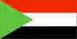
Today, it is featuring the Sudan, a country that is out of the news at the moment but where Christians continue to make a great impact despite seemingly impossible odds against them. Do check the site out; it gives helpful
insights to pray for this country which boasts that it is the African leader of the Islamic Revolution. Khartoum is now reputed to have way over twelve million people.
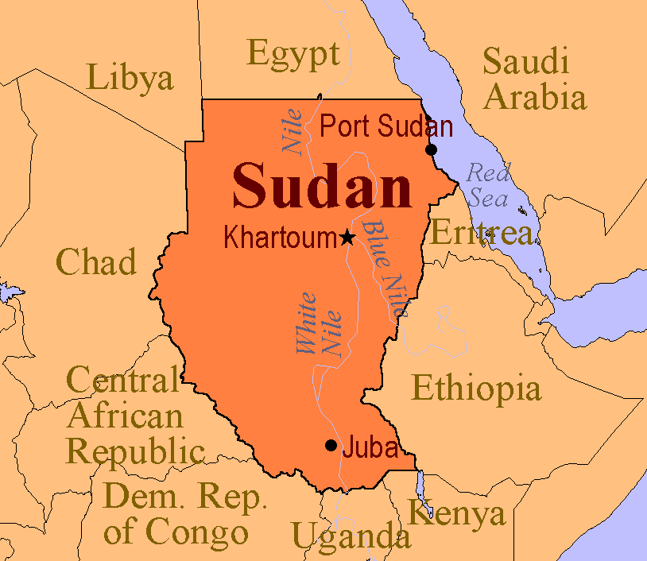

Ruach (Breath of Life) Ministries
The Manse, Station Rd, Halwill Junction, Devon, EX21 5XB

